Term | Autumn 1 | Autumn 2 | Spring 1 | Spring 2 | Summer 1 | Summer 2
Leading Questions  (LCC question) | Who lives in my house?  (All about me)  Mum/dad/brothers and sisters– People who help me  Change over time (in relation to growing up / getting older).  Houses and homes. | Where does the day go at night?  (Planets and places around the world)  Naming planets.  Light and dark. Shadows.  Autumn time. | How do I get about?  (Has the world always been like this?)  Different modes of transport  Old and new transport | What would you find at the farm?  (What animals are alive now?)  Animal life cycle.  Spring – Growing plants from seeds.  Farm themed day. | Who goes to the ugly bug ball?  (How do animals and other things grow?)  Life cycle of a chick.  Spring – Growing plants from seeds. | What can I do with water?  (How can I take care of our planet?)  Beach holidays.  Floating & sinking.  Explore capacity by pouring into different shaped and sized containers.  Under the sea
Key Questions | What is special about me?  Who else lives in my house and what are they called? What is special about my family?  What is my house made of?  What is my house address?  What can I see out of the window?  Who visits my house? | What happens when I am asleep?  Why does the Owl mummy fly away?  Where are the stars in the day?  Why do I go to sleep?  What noises can you hear at night?  Can I get rid of my shadow? | How do I get to school?  Why are the wheels on the bus round?  How can Little Red Riding Hood get to grandma’s house safely?  Could Thomas The Tank Engine travel on the road? Could Rory The Racing Car travel on the tracks?  Where would I go to if I wanted to travel to Pakistan? | Why did Old McDonald have a farm?  Why would a farmer keep some cows?  What happens to the eggs?  Where does my woolly jumper come from?  Why is it important to have tractors on a farm?  Which foods in Morrisons come from the farm? | Why is a caterpillar always hungry?  Who lives underneath the grass/stone/logs?  What lurks in the pond?  How can we make a happy home for our ugly bugs?  What do we need to do to prepare for the Ugly Bug Ball?  Who would you go as to the Ugly Bug Ball? | What does Mrs Wishy Washy do?  How can I make bubbles? (Pig in the Pond)  Why did Noah build an ark?  What would you see at the seaside? (The Train Ride)  Can I make some friends for the Rainbow Fish?  Where do puddles go?
Reflection  (end point) | A walk around the locality finding the park, shops and houses. Bringing parents along too further embeds this challenge | Shadow theatre and fun in the blackout tent. | Making wheeled vehicles with ‘junk’. Can we make a car big enough for someone to sit in! | Watch the eggs hatch in the incubator or make your own farm with children dressing as animals and building pens for each other | The Ugly Bug Ball! | Set some simple challenges for outdoor exploration. Can children move water from one place to another without using a bucket and what happens to the cardboard box when it rains?
Literacy Focus | 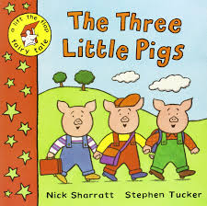  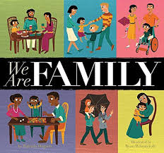  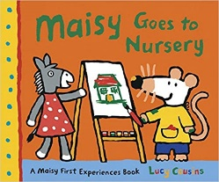 | 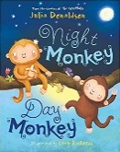  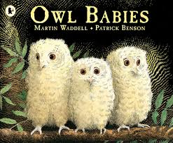  The Christmas Story | 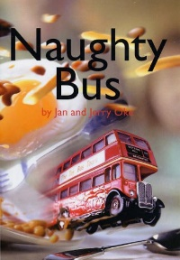  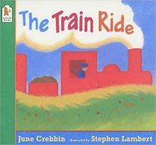  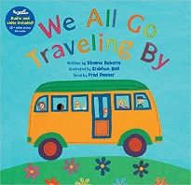 | 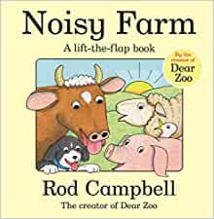  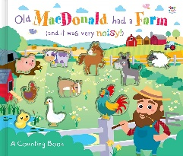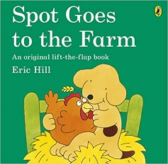 | 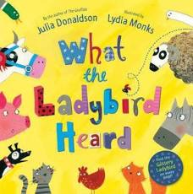  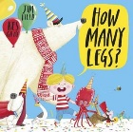  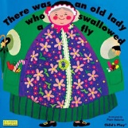 | 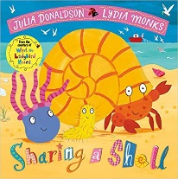  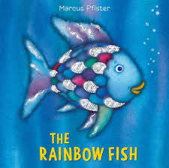  Non-fiction books about water.
Communication and language | - Enjoy listening to longer stories and can remember much of what happens.  - Can find it difficult to pay attention to more than one thing at a time.  - Use a wider range of vocabulary.  - Understand a question or instruction that has two parts, such as “Get your coat and wait at the door”.  - Understand ‘why’ questions, like: “Why do you think the caterpillar got so fat?”  - Sing a large repertoire of songs.  - Know many rhymes, be able to talk about familiar books, and be able to tell a long story.  - Develop their communication, but may continue to have problems with irregular tenses and plurals, such as ‘runned’ for ‘ran’, ‘swimmed’ for ‘swam’.  - May have problems saying:- some sounds: r, j, th, ch, and sh- multisyllabic words such as ‘pterodactyl’, ‘planetarium’ or ‘hippopotamus’  - Use longer sentences of four to six words.  - Be able to express a point of view and to debate when they disagree with an adult or a friend, using words as well as actions.  - Can start a conversation with an adult or a friend and continue it for many turns.  - Use talk to organise themselves and their play: “Let’s go on a bus... you sit there... I’ll be the driver.”
Literacy | - Understand the five key concepts about print:- print has meaning - the names of the different parts of a book- print can have different purposes - page sequencing- we read English text from left to right and from top to bottom  - Develop their phonological awareness, so that they can:- spot and suggest rhymes- count or clap syllables in a word- recognise words with the same initial sound, such as money and mother  - Engage in extended conversations about stories, learning new vocabulary.  - Use some of their print and letter knowledge in their early writing. For example: writing a pretend shopping list that starts at the top of the page; write ‘m’ for mummy.  - Write some or all of their name.  - Write some letters accurately.
Mathematics | Fast recognition of up to 3 objects, without having to count them individually (‘subitising’).  - Recite numbers past 5.  - Say one number for each item in order: 1,2,3,4,5.  - Know that the last number reached when counting a small set of objects tells you how many there are in total (‘cardinal principle’).  - Show ‘finger numbers’ up to 5.  - Link numerals and amounts: for example, showing the right number of objects to match the numeral, up to 5.  - Experiment with their own symbols and marks as well as numerals.  - Solve real world mathematical problems with numbers up to 5.  - Compare quantities using language: ‘more than’, ‘fewer than’.  - Talk about and explore 2D and 3D shapes (for example, circles, rectangles, triangles and cuboids) using informal and mathematical language: ‘sides’, ‘corners’; ‘straight’, ‘flat’, ‘round’.  - Understand position through words alone – for example, “The bag is under the table,” – with no pointing.  - Describe a familiar route.  - Discuss routes and locations, using words like ‘in front of’ and ‘behind’.  - Make comparisons between objects relating to size, length, weight and capacity.  - Select shapes appropriately: flat surfaces for building, a triangular prism for a roof etc.  - Combine shapes to make new ones – an arch, a bigger triangle etc.  - Talk about and identifies the patterns around them. For example: stripes on clothes, designs on rugs and wallpaper. Use informal language like ‘pointy’, ‘spotty’, ‘blobs’ etc.  - Extend and create ABAB patterns – stick, leaf, stick, leaf.  - Notice and correct an error in a repeating pattern.  - Begin to describe a sequence of events, real or fictional, using words such as ‘first’, ‘then...’
Personal, Social and Emotional Development | Select and use activities and resources, with help when needed. This helps them to achieve a goal they have chosen, or one which is suggested to them.  • Develop their sense of responsibility and membership of a community.  • Become more outgoing with unfamiliar people, in the safe context of their setting.  • Show more confidence in new social situations.  • Play with one or more other children, extending and elaborating play ideas.  • Help to find solutions to conflicts and rivalries. For example, accepting that not everyone can be Spider-Man in the game, and suggesting other ideas.  • Increasingly follow rules, understanding why they are important.  • Do not always need an adult to remind them of a rule.  • Develop appropriate ways of being assertive.  • Talk with others to solve conflicts.  • Talk about their feelings using words like ‘happy’, ‘sad’, ‘angry’ or ‘worried’.  • Begin to understand how others might be feeling.
Physical Development | Continue to develop their movement, balancing, riding (scooters, trikes and bikes) and ball skills.  - Go up steps and stairs, or climb up apparatus, using alternate feet.  - Skip, hop, stand on one leg and hold a pose for a game like musical statues.  - Use large-muscle movements to wave flags and streamers, paint and make marks.  - Start taking part in some group activities which they make up for themselves, or in teams.  - Are increasingly able to use and remember sequences and patterns of movements which are related to music and rhythm.  - Match their developing physical skills to tasks and activities in the setting. For example, they decide whether to crawl, walk or run across a plank, depending on its length and width.  - Choose the right resources to carry out their own plan. For example, choosing a spade to enlarge a small hole they dug with a trowel.  - Collaborate with others to manage large items, such as moving a long plank safely, carrying large hollow blocks.  - Use one-handed tools and equipment, for example, making snips in paper with scissors.  - Use a comfortable grip with good control when holding pens and pencils.  - Start to eat independently and learning how to use a knife and fork.  - Show a preference for a dominant hand.  - Be increasingly independent as they get dressed and undressed, for example, putting coats on and doing up zips.  - Be increasingly independent in meeting their own care needs, e.g. brushing teeth, using the toilet, washing and drying their hands thoroughly.  - Make healthy choices about food, drink, activity and toothbrushing.
Understanding the World | - Use all their senses in hands-on exploration of natural materials.  - Explore collections of materials with similar and/or different properties.  - Talk about what they see, using a wide vocabulary.  - Begin to make sense of their own life-story and family’s history.  - Show interest in different occupations.  - Explore how things work.  - Plant seeds and care for growing plants.  - Understand the key features of the life cycle of a plant and an animal.  - Begin to understand the need to respect and care for the natural environment and all living things.  - Explore and talk about different forces they can feel.  - Talk about the differences between materials and changes they notice.  - Continue to develop positive attitudes about the differences between people.  - Know that there are different countries in the world and talk about the differences they have experienced or seen in photos.
Phonics | Rhymes and songs:  - Twinkle Twinkle  - 1,2,3,4,5  - If you’re Happy and You know it  - Head shoulders knees and toes  - Miss Polly had a dolly  - The hokey pokey  Phonics  - Phase 1 games  - Oral blending/  segmenting | Rhymes and songs:  - Hickory Dickory Dock  - Goldilocks and the three bears  Phonics  - Phase 1 games  - Oral blending/  segmenting | Rhymes and songs:  - Hey diddle diddle  - Jack and Jill  - Incy wincy spider  - Little men in a flying saucer  - The wheels on the bus  Phonics  - Phase 1 games  - Oral blending/  segmenting | Rhymes and songs:  - Hickory Dickory Dock  - Mary had a little Lamb  - Humpty Dumpty  - Baa baa black sheep  Phonics  - Phase 1 games  - Oral blending/  segmenting | Rhymes and songs:  - The Dingle Dangle Scarecrow  - Old Macdonald  - Little Bo Peep Five Little Ducks  - Incy wincy spider  Phonics  - Phase 1  - Introduce RWI | Rhymes and songs:  - Row, Row Row Your Boat  - Wind the bobbin up  - I’m a little teapot  - Five little ducks  Phonics  - Phase 1  - Introduce RWI
Visitors/Trips /First hand opportunities | Family day – Teddy bears picnic - parents invited into school.  Walk around the local area | Walk around the local area/  environment to explore and observe the signs of autumn.  Owl visit. | Walk around the local area/  environment to explore and observe the signs of winter. | Life cycle of a chick/  Chick incubator.  Walk around the local area/  environment to explore and observe the signs of spring.  Mobile farm visit. | Bug Man.  Life cycle of a chick (watch eggs hatch)  Character Costume Day. | Walk around the local area/  environment to explore and observe the signs of summer.  - Summer fun day.
British Values | Halloween  Diwali | Bonfire Night Gunpowder Plot  Remembrance Day  Christmas | Chinese New Year  Valentine’s Day | Pancake Day  Mother’s Day  Easter  World Book Day | Eid | Father’s Day  Sports Day

