Thursday 26rd May 2022
Jamf Parents App
The Jamf Parent app allows Parents to control how children can use their school issued iPads. It allows you to set rules for what apps are available and for how long.
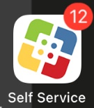
The Parents App will only work after 6pm and you will be able to set your own rules by following these simple steps:
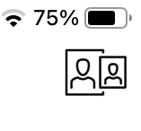
- On your child’s iPad, open Self Service.

- Click this symbol in the top right corner of the screen

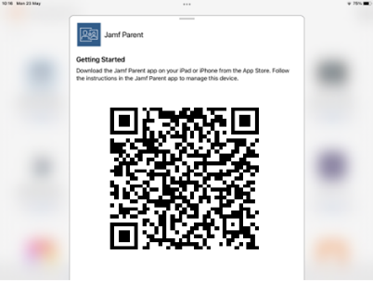
- This will show you a QR code which you can scan on your phone to connect to your child’s iPad. This QR code is unique to you child.

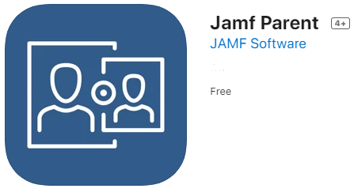
- Download Jamf Parent on your phone using the App Store or the Google Play Store.

- Scan your child’s QR code and you will now be linked to your chid’s iPad, you should only have to do this process one time.

- Select your child’s name

- Now you can restrict what types of apps are available to your child while at home. This will disable them for a short amount of time.

- If you would like to set a schedule for certain types of apps e.g. no games after 8pm, you can do this by clicking ‘Device Rules’

If you have any further questions, please contact Mr Woodyet (Horizons lead) via the Main Office.



