Forest School Club – Activity 9
Nature Alphabet/Numbers/Names

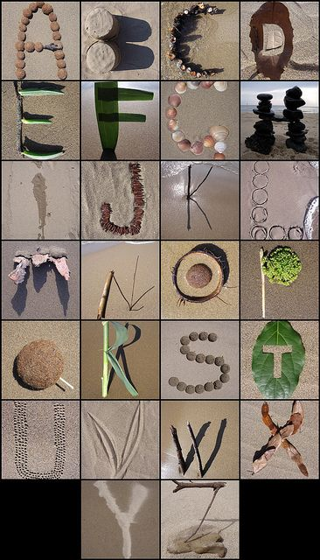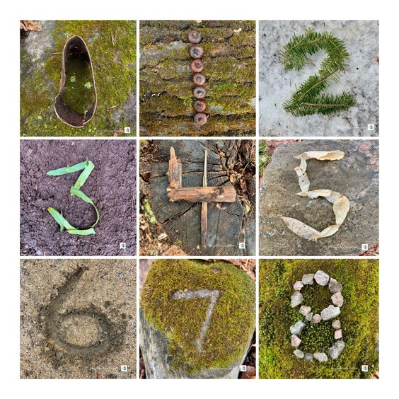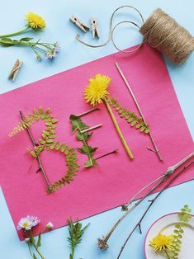

This week’s activity is to collect natural materials from around your garden/yard, or if going on a family walk around the park/open space, and use them to create different representations.

Can you create the alphabet? Can you create numbers? Can you create your name?

Have fun and I can’t wait to see photographs of what you have made
Post them on your class Dojo page or on Tapestry.
Miss Seed x x
